Updating/Installing Oxygen XML Editor

- If Oxygen XML Editor has been previously installed on your MacBook Pro, browse to the Applications folder to locate your existing oxygen folder. If Oxygen XML Editor has NOT been previously installed, skip to Step 3.

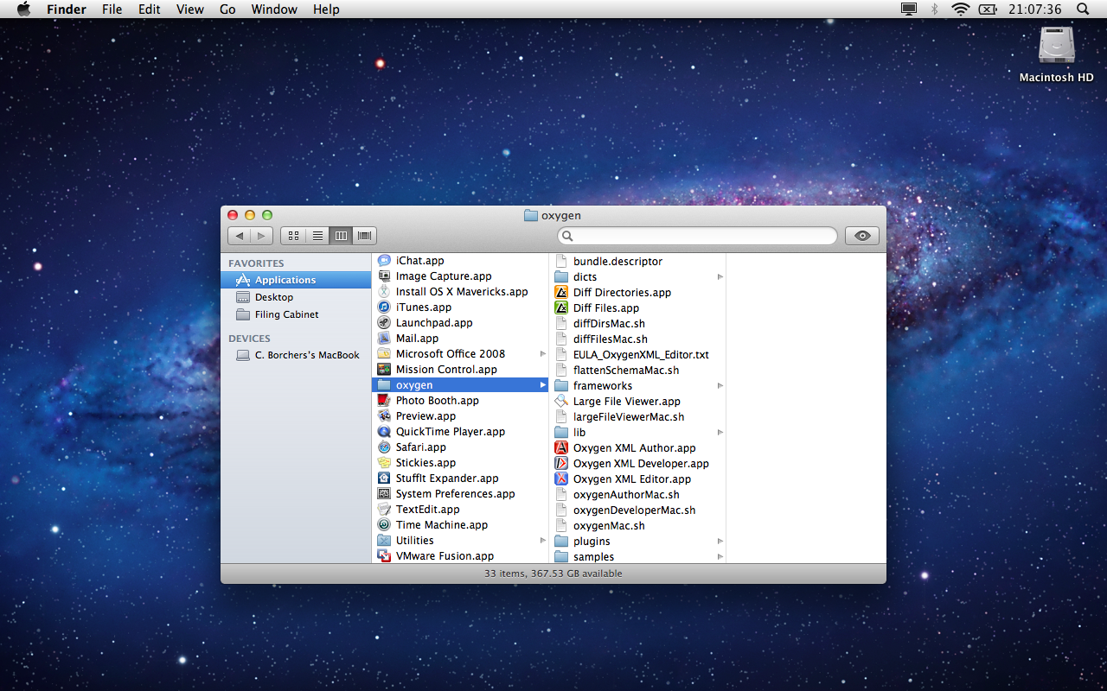

- DRAG your existing oxygen folder to the Trash—removing it from the Applications folder.

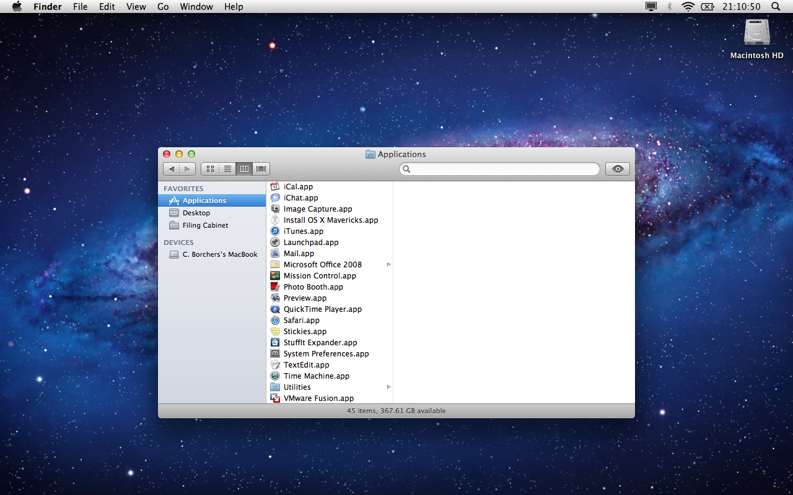

- Open Dropbox, navigate to Digital Humanities Group\All\Software\Mac, and locate Oxygen XML Editor… for Mac.zip.

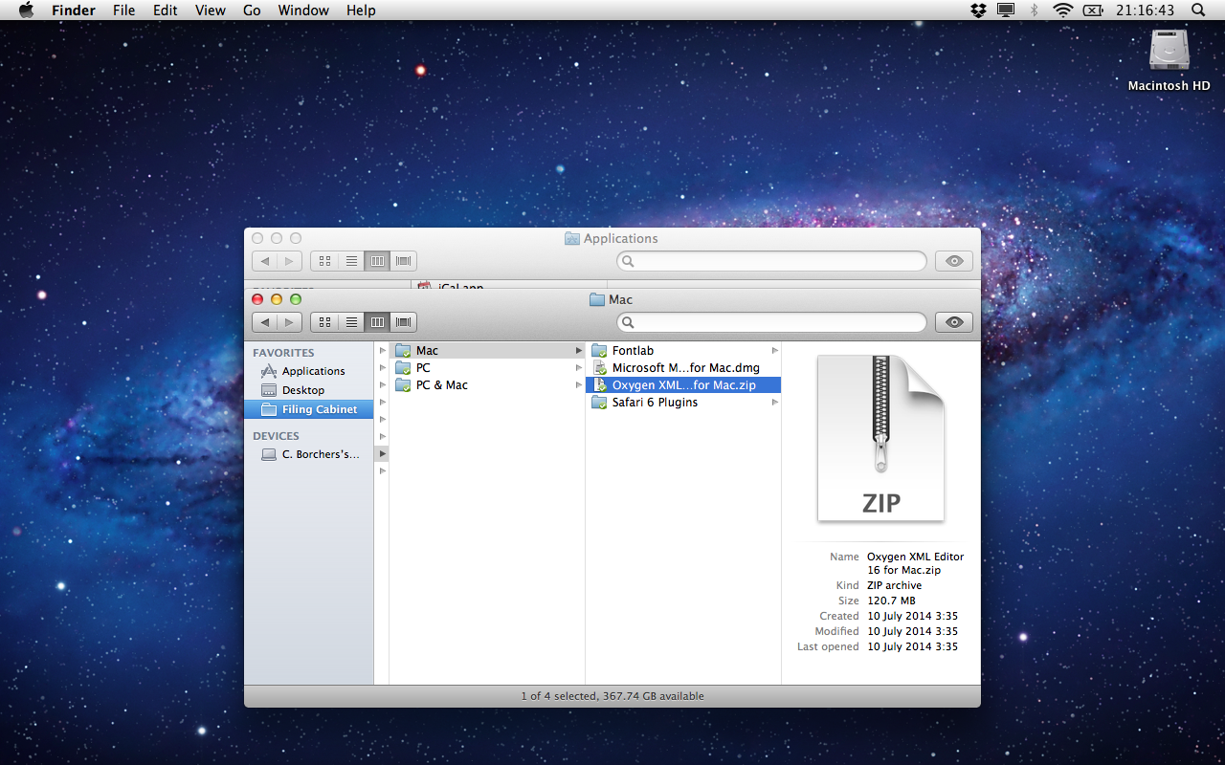

- COPY AND PASTE Oxygen XML Editor… for Mac.zip to your Desktop.

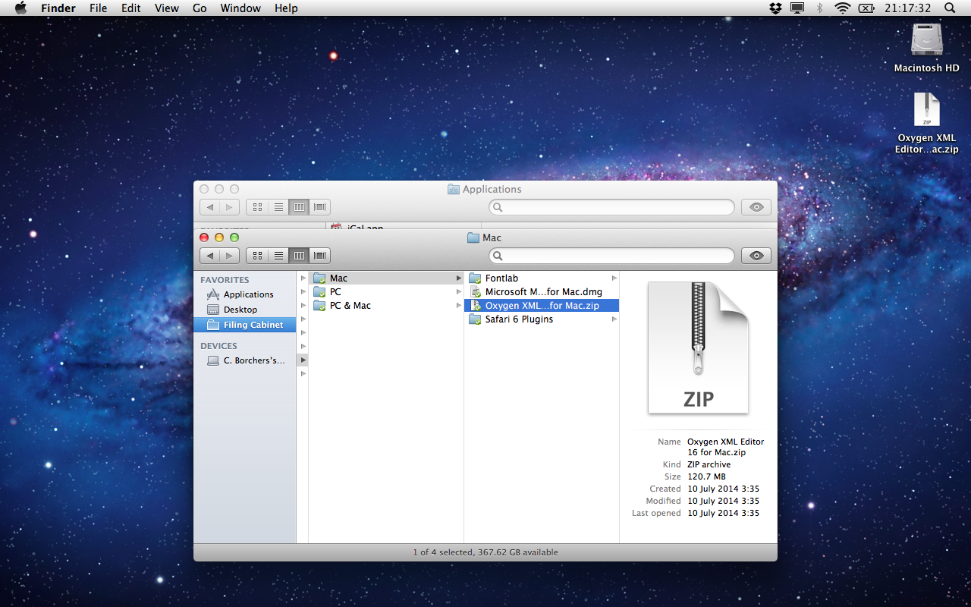

- Double-click Oxygen XML Editor… for Mac.zip on your Desktop. This will create a new oxygen folder.

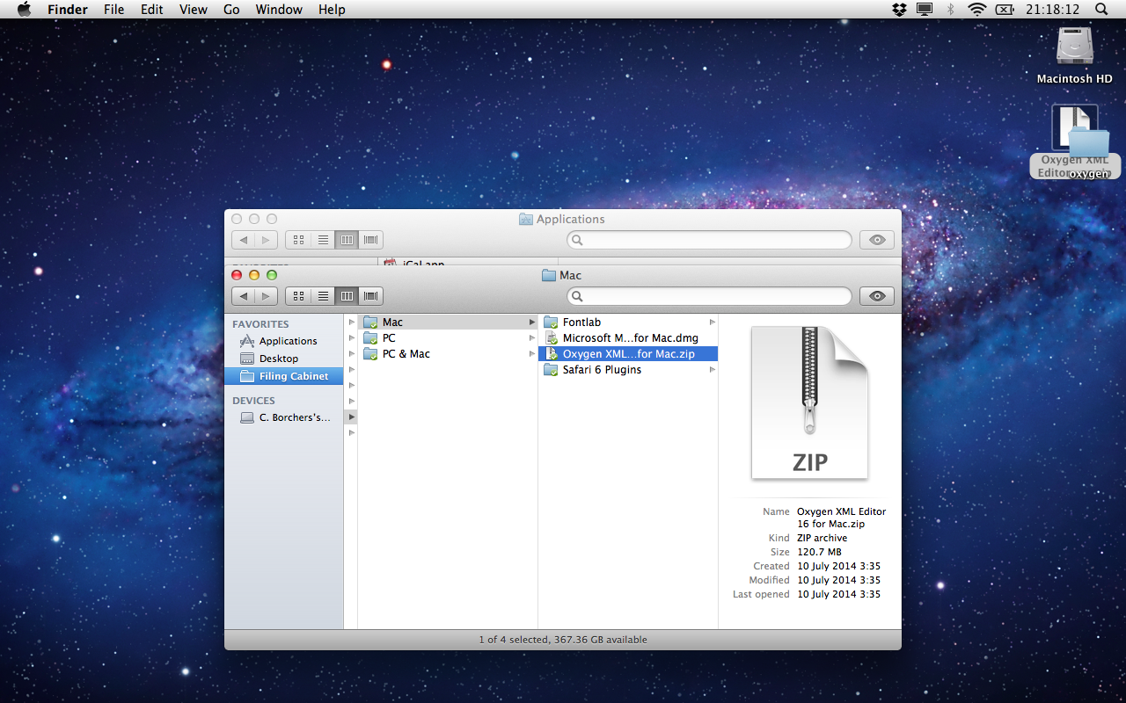

- DRAG the newly-created oxygen folder from your Desktop to Applications.

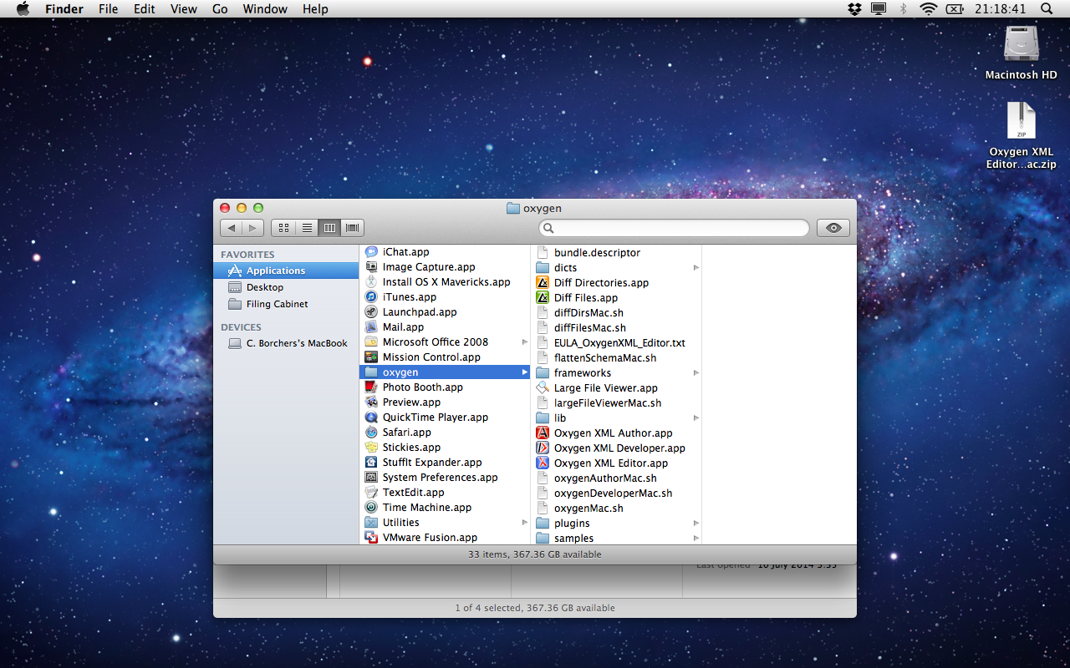

- Locate Oxygen XML Editor.app in the oxygen folder and double-click it to launch Oxygen XML Editor.

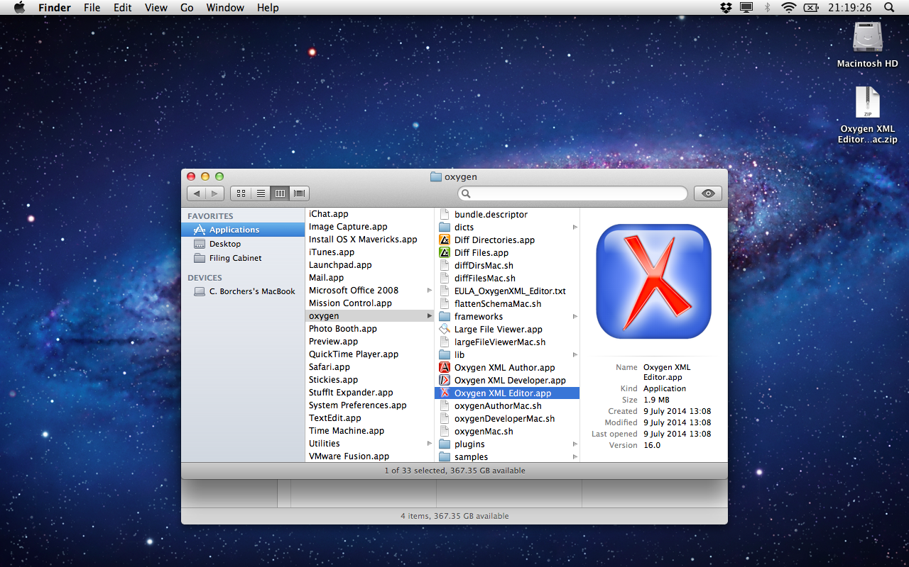

- If Oxygen XML Editor has been previously registered on your MacBook Pro, skip to Step 14. If Oxygen XML Editor has NOT been previously registered OR if you are prompted to purchase a license when launching the app, click Help, then Register….

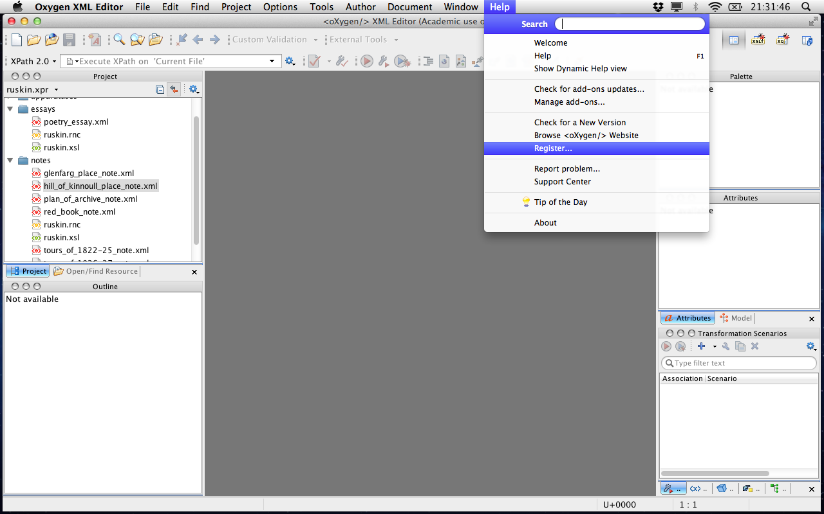

- The Oxygen XML Editor License window will appear.

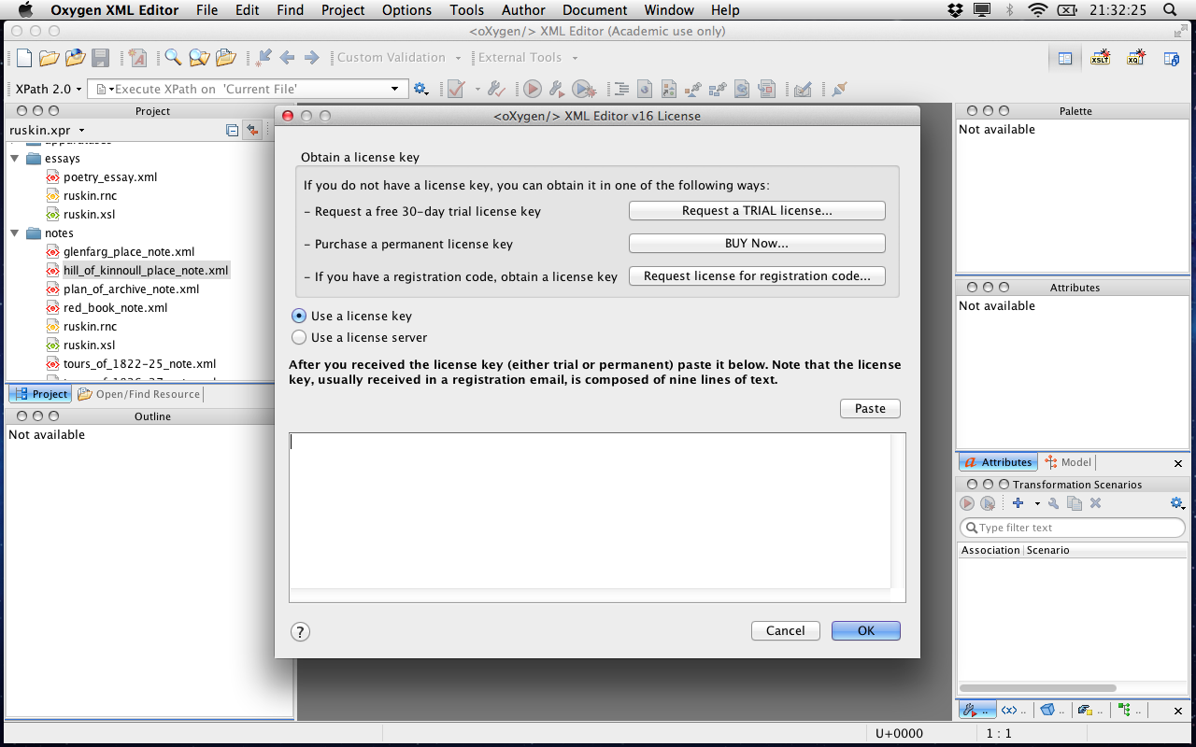

- Return to Dropbox, navigate to Digital Humanities Group\All\Documentation, and double-click Oxygen XML Registration Instructions.doc.

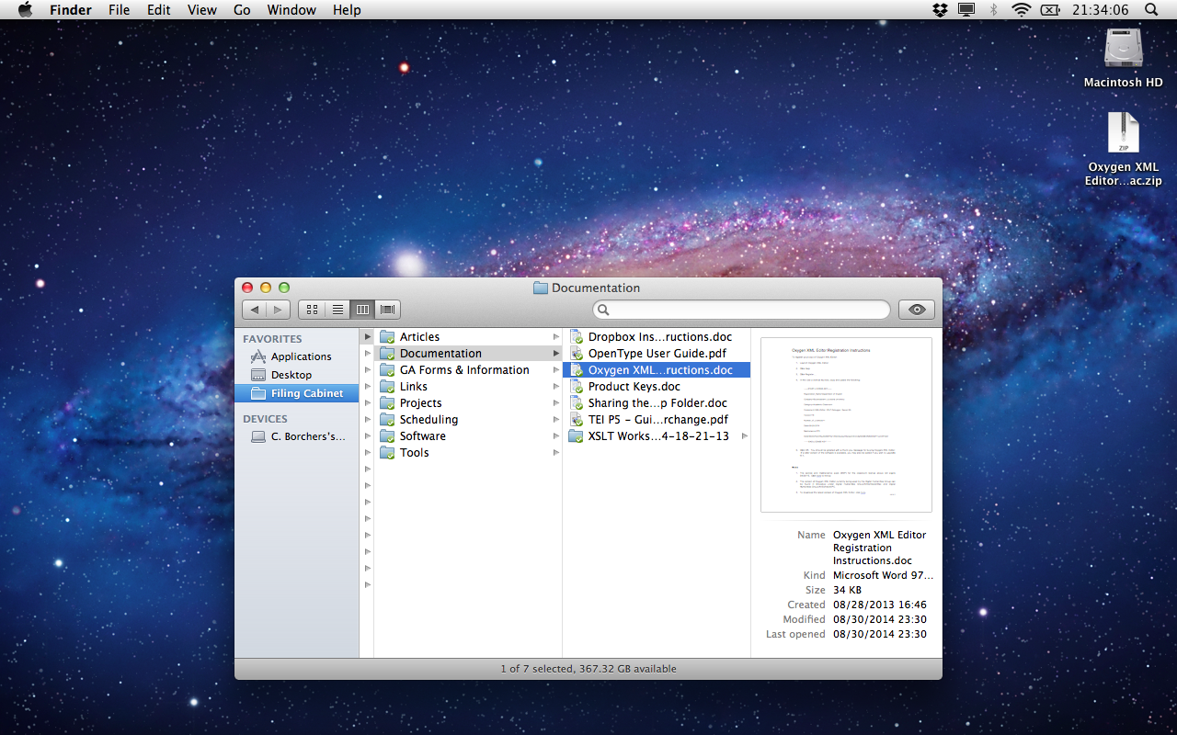

- In Oxygen XML Registration Instructions.doc, locate and copy the license key as shown.

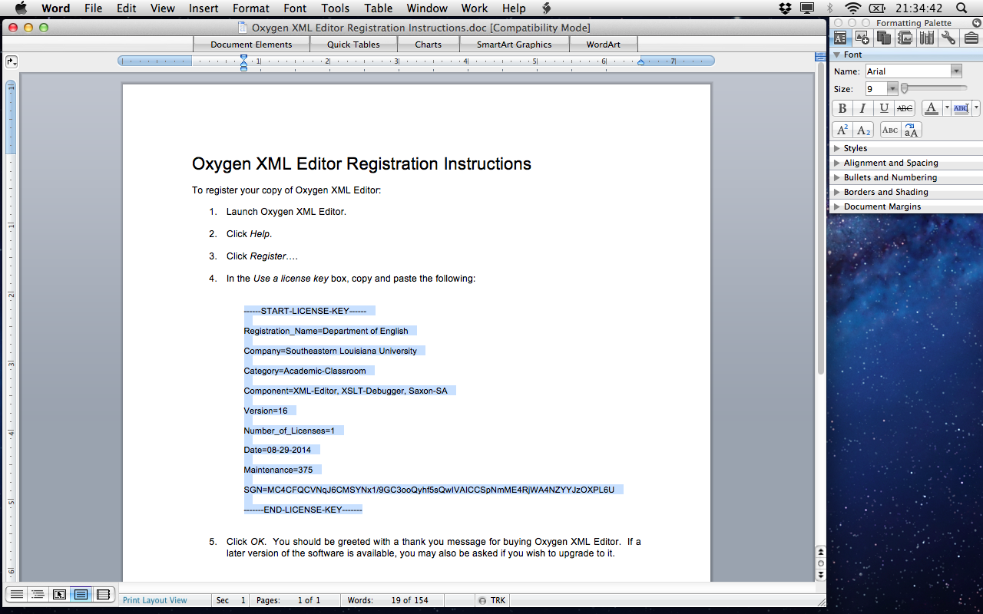

- Return to Oxygen XML Editor, paste the license key into the Oxygen XML Editor License window, and click OK.

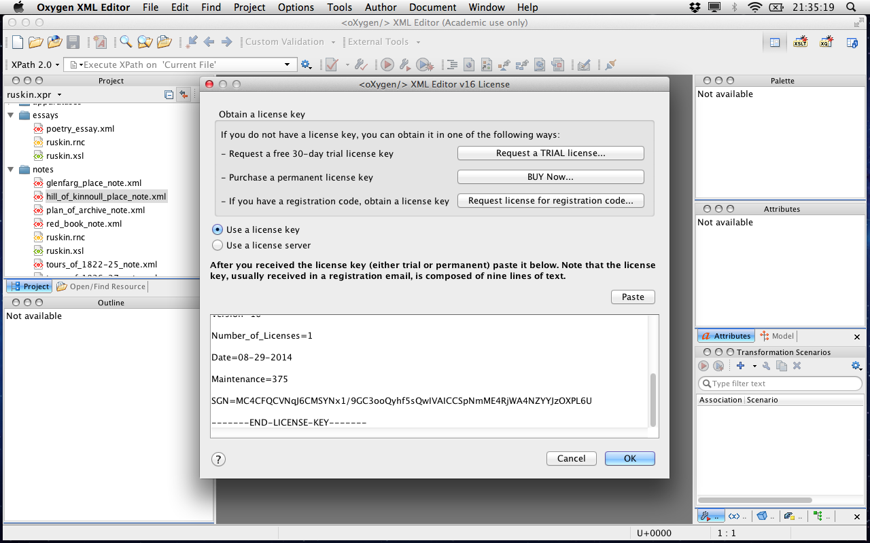

- When the Registration successful/Thank you for buying Oxygen XML Editor! box appears, click OK.

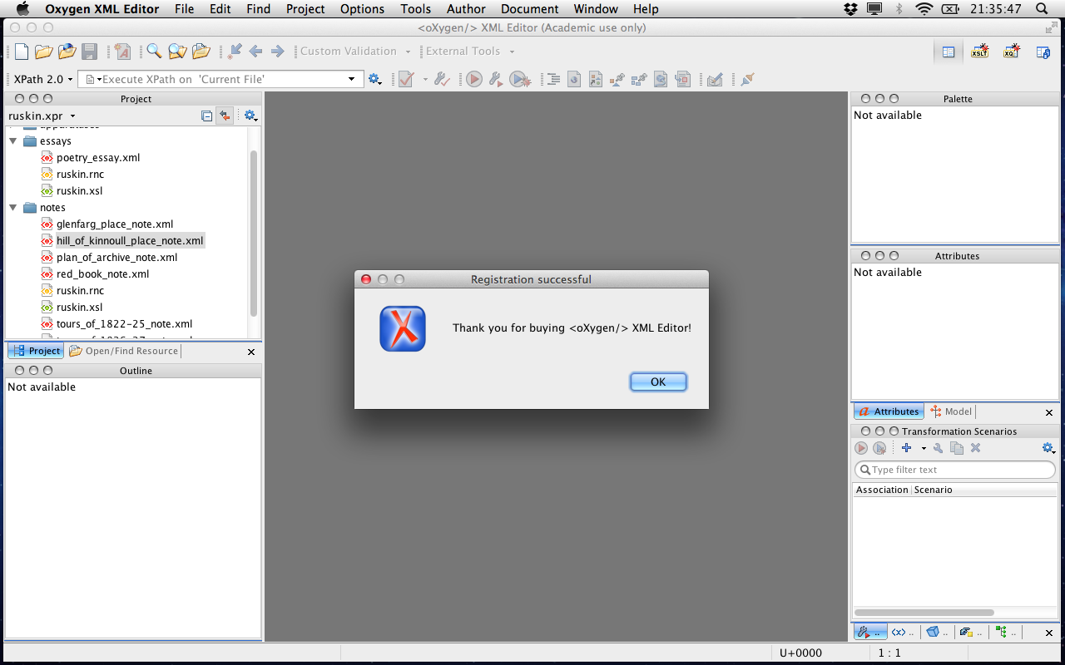

- Open any XML file.

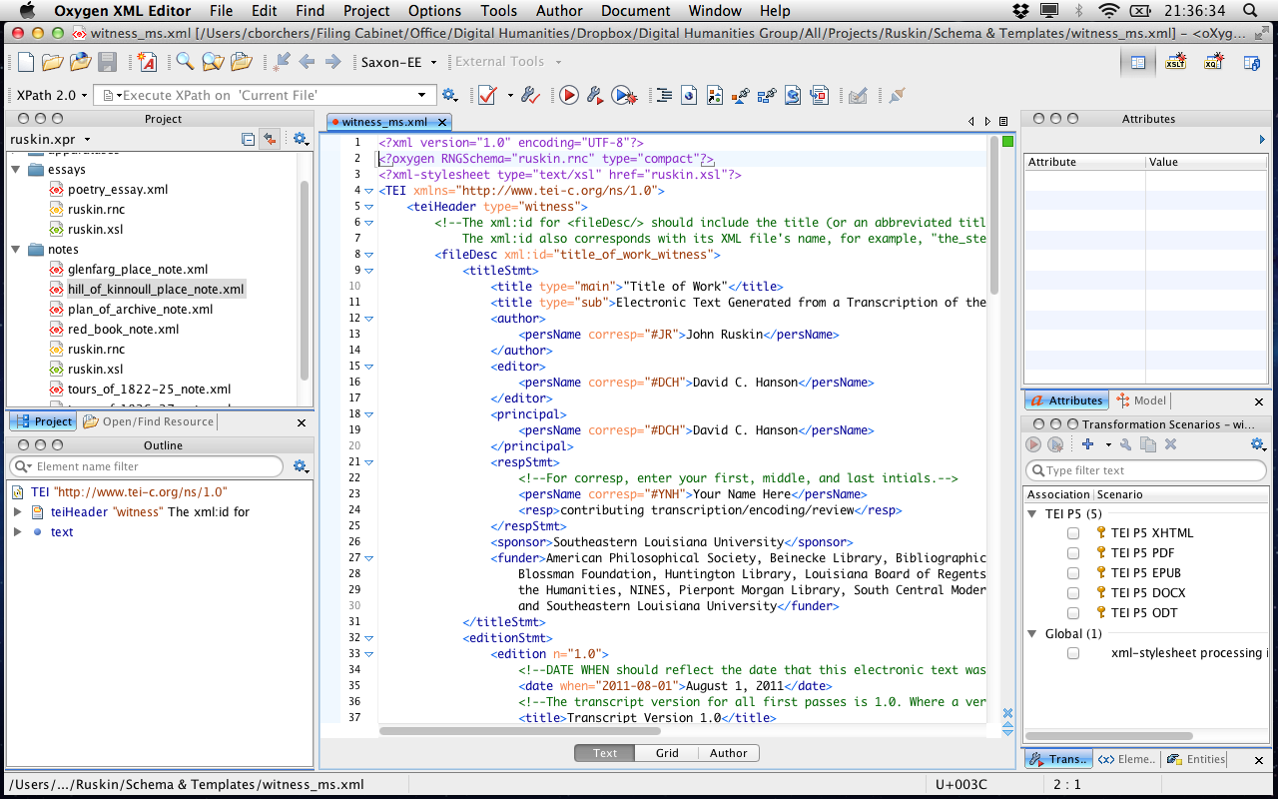

- Close the surrounding sidebars to maximize your workspace. Oxygen XML Editor will remember this workspace when relaunched.

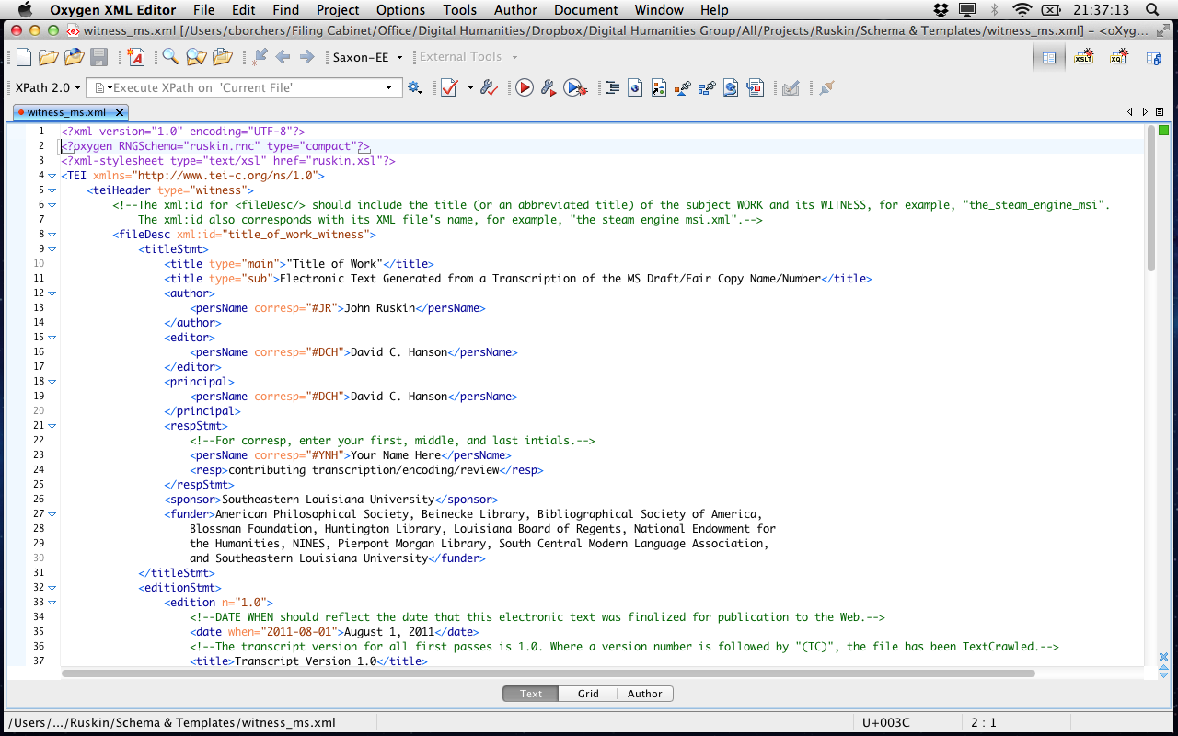

- Return to Oxygen XML Registration Instructions.doc and close the document. DO NOT SAVE CHANGES IF PROMPTED.

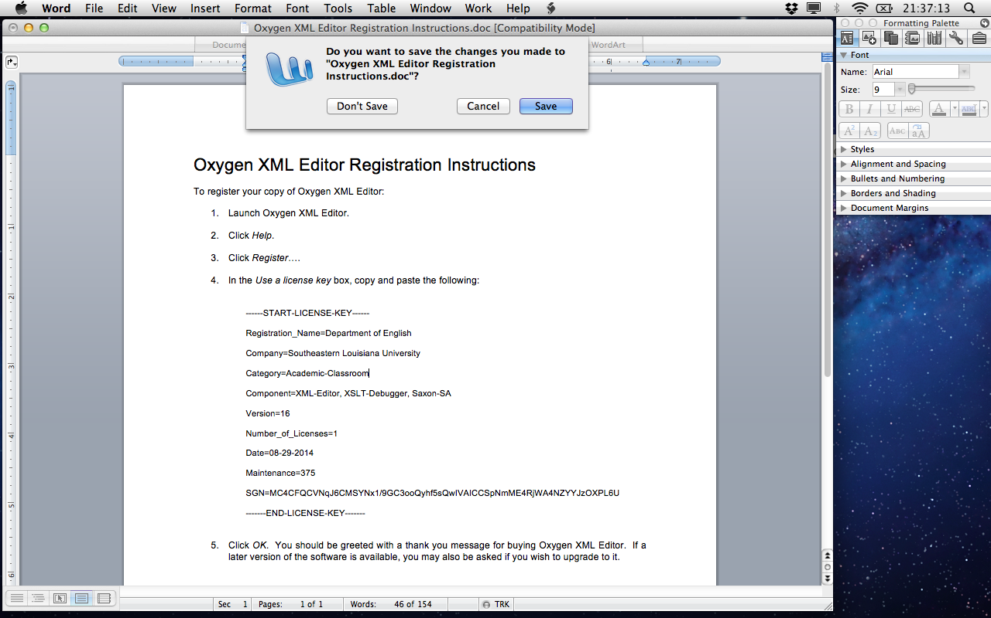

- Return to your Desktop and DRAG Oxygen XML Editor… for Mac.zip to the Trash.

